**TDD using Junit5 and Mockito**

**Exercise 1:**

**Setting up Junit:**

JunitEx pom.xml:

<project xmlns="http://maven.apache.org/POM/4.0.0" xmlns:xsi="http://www.w3.org/2001/XMLSchema-instance" xsi:schemaLocation="http://maven.apache.org/POM/4.0.0 https://maven.apache.org/xsd/maven-4.0.0.xsd">

<modelVersion>4.0.0</modelVersion>

<groupId>com.geetha</groupId>

<artifactId>JunitEx</artifactId>

<version>0.0.1-SNAPSHOT</version>

<dependencies>

<!-- ✅ JUnit 4 Dependency -->

<dependency>

<groupId>junit</groupId>

<artifactId>junit</artifactId>

<version>4.13.2</version>

<scope>test</scope>

</dependency>

</dependencies>

</project>

**Simple test cases:**

SimpleMath.java:

**package** com.geetha.core;

**public** **class** SimpleMath {

**public** **int** add(**int** a, **int** b) {

**return** a + b;

}

**public** **int** multiply(**int** a, **int** b) {

**return** a * b;

}

}

Simple MathTest.java:

**package** com.geetha.test;

**import** com.geetha.core.SimpleMath;

**import** org.junit.Test;

**import** **static** org.junit.Assert.*;

**public** **class** SimpleMathTest {

@Test

**public** **void** testAddition() {

SimpleMath math = **new** SimpleMath();

*assertEquals*(10, math.add(6, 4));

}

@Test

**public** **void** testMultiplication() {

SimpleMath math = **new** SimpleMath();

*assertEquals*(24, math.multiply(6, 4));

}

}

**output:**  
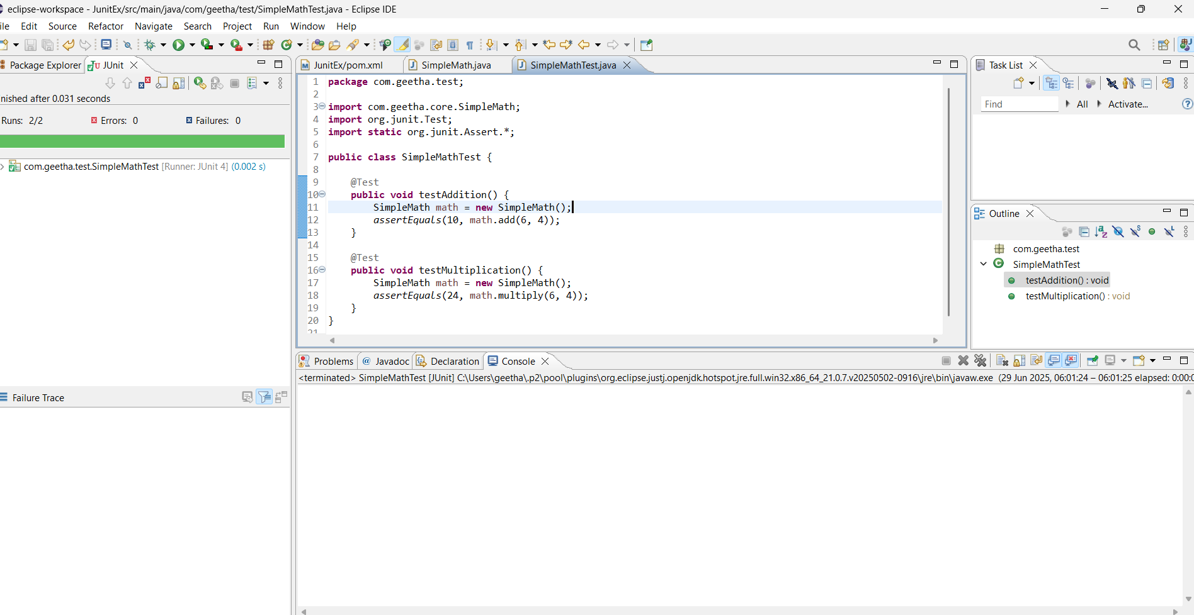

**Exercise 3:**

**Assertions in Junit:**

**package** com.geetha.test;

**import** **static** org.junit.Assert.*;

**import** org.junit.Test;

**public** **class** AssertionsTest {

@Test

**public** **void** testAssertions() {

// Assert Equals

*assertEquals*(5, 2 + 3);

// Assert True

*assertTrue*(5 > 3);

// Assert False

*assertFalse*(2 > 5);

// Assert Null

*assertNull*(**null**);

// Assert Not Null

*assertNotNull*(**new** Object());

}

}

**Output:**  
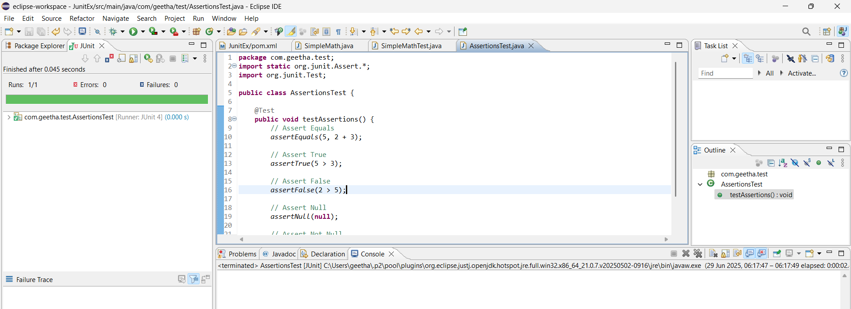

**Exercise 4:  
Arrange-Act-Asser Pattern,Test fixtures,Setup and teardown Methods in Junit:**

SimpleCalculator.Java:

**package** com.geetha.core;

**public** **class** SimpleCalculator {

**public** **int** add(**int** a,**int** b)

{

**return** a+b;

}

**public** **int** mul(**int** a,**int** b)

{

**return** a*b;

}

**public** **int** div(**int** a,**int** b)

{

**return** a/b;

}

**public** **int** sub(**int** a,**int** b)

{

**return** a-b;

}

}

SimpleCalculatorTest.java:

**package** com.geetha.test;

**import** com.geetha.core.SimpleCalculator;

**import** org.junit.Before;

**import** org.junit.After;

**import** org.junit.Test;

**import** **static** org.junit.Assert.*;

**public** **class** SimpleCalculatorTest {

**private** SimpleCalculator calculator;

@Before

**public** **void** setUp() {

calculator = **new** SimpleCalculator();

System.***out***.println("Setup complete");

}

@After

**public** **void** tearDown() {

calculator = **null**;

System.***out***.println(" Teardown complete");

}

@Test

**public** **void** testAddition() {

**int** a = 10;

**int** b = 5;

**int** result = calculator.add(a, b);

*assertEquals*(15, result);

}

**public** **void** testDivision() {

**int** a = 20;

**int** b = 4;

**int** result = calculator.div(a, b);

*assertEquals*(5, result);

}

**public** **void** testMultiply()

{

**int** a=3;

**int** b=2;

**int** result=calculator.mul(a, b);

*assertEquals*(6,result);

}

**public** **void** testSubtraction()

{

**int** a=9;

**int** b=2;

**int** result=calculator.sub(a, b);

*assertEquals*(7,result);

}

}

**Output:**  
